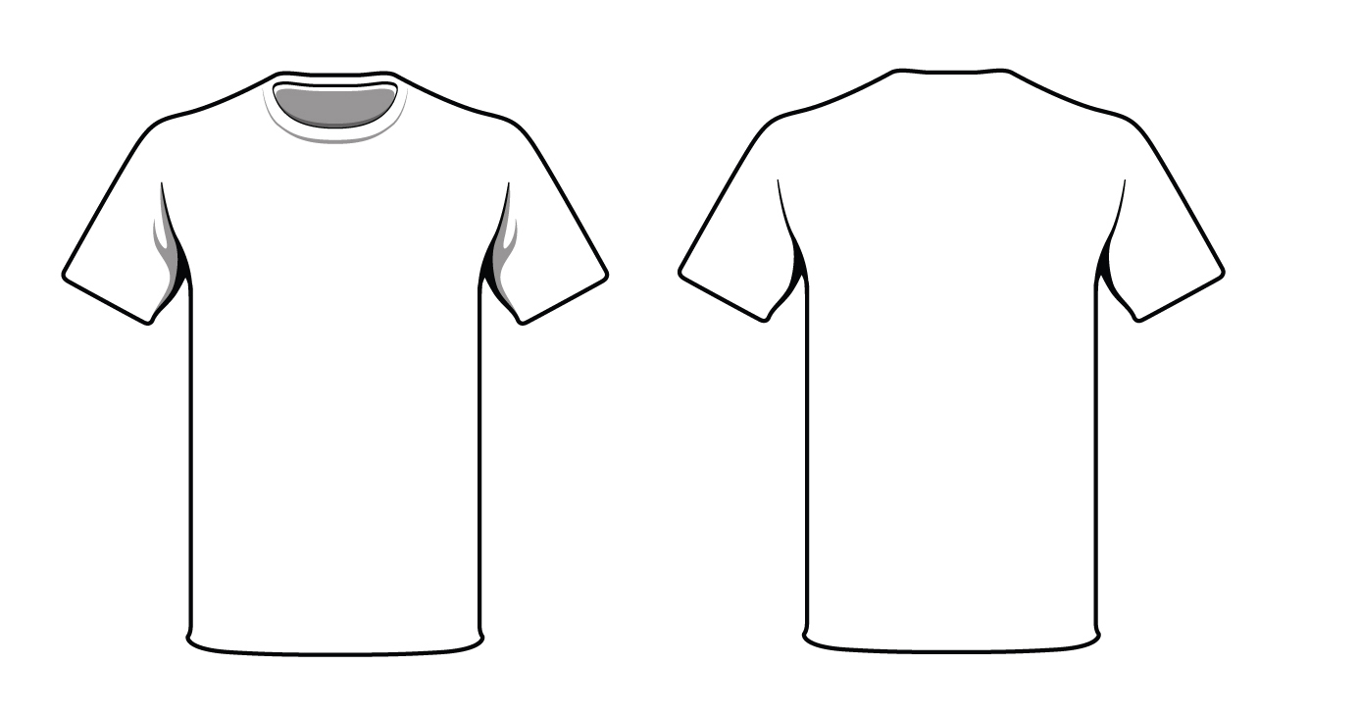
Cardinal
Athletics
Competition
Cheer
2020-2021
Sponsors
Name of Cheerleader:
Option 1  Business Name on Competition  T-shirts  Business name will be printed on over 50  t-shirts worn at every competition | Option 2  Name & number on banner at the gym  Business name will be printed on banner displayed at the cardinal gym | Option 3  Name & number or email on Competition  T-shirts  Business name and number will be printed on over 50 t-shirts worn at every competition | Option 4  Banner & T-shirt Sponsor  Business name will be printed on over 50  t-shirts worn at every competition and Business Logo will be displayed on a large banner in our new Gym
$100.00 | $150.00 | $200.00 | $300.00
Option# | Name | Price
Signature
Please make check out to Cardinal Athletics
Thank you for your Support!

